**Group 12- Bigger is Better**

*June 19, 2019*

As aviation keeps growing, so does the concern about the impact on the climate, local air quality and the noise generated by aircraft. Especially the way the aviation keeps growing is concerning; as found from a market analysis new aircraft tend to fly further than ever, while the passenger flows on short range routes keep increasing. This results in the aircraft being used far below their design specifications, which in turn leads to a suboptimal performance in terms of emissions and fuel consumption. The goal of this project was thus to develop a short range fixed wing aircraft capable of carrying 450 passengers which supports the sustainable growth of aviation. To drive the sustainability aspect of the aircraft, requirements regarding the fuel consumption, noise and cruise conditions were imposed. The fuel consumption namely had to be 10% less than current state of the art aircraft (B737-MAX and A320-NEO). Other requirements related to this project concerned the range, which was to be determined from the market analysis, operating costs, field performance and operational handling.

The first step taken in the design process was assessing how these requirements would drive the design.

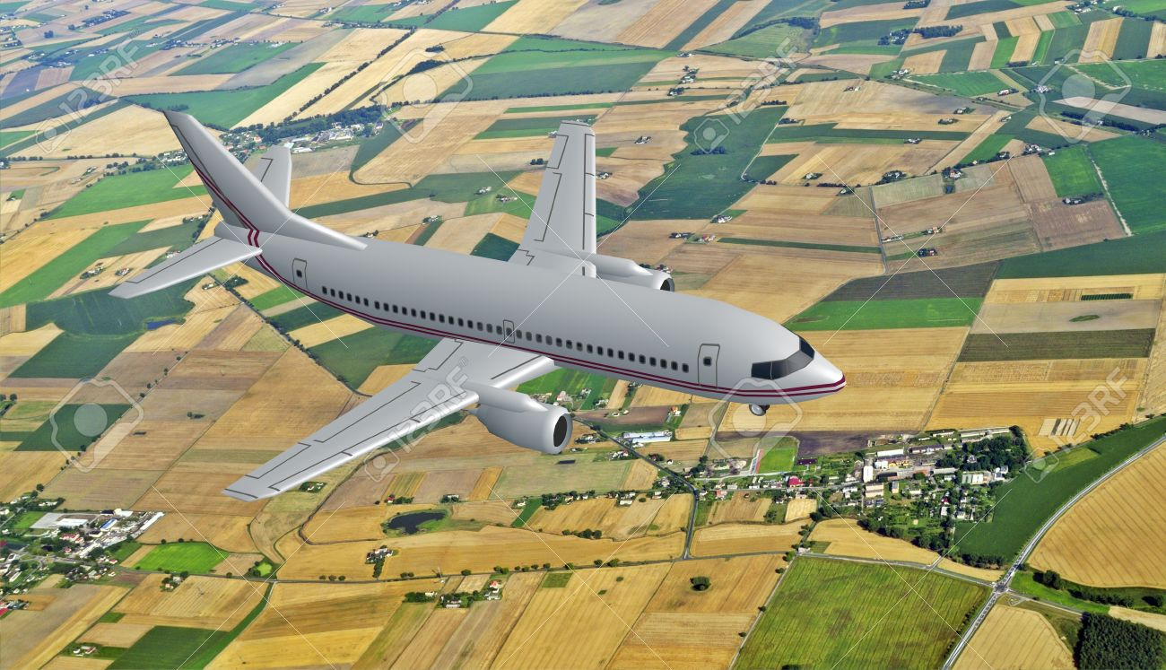

Figure 1 - <Caption for photo>